Part 1 – Data Description
Data Set 1
- Name: Thyroid Disease Data Set – Hypothyroid Data
- Source: UCI Machine Learning Repository
https://archive.ics.uci.edu/ml/datasets/Thyroid+Disease
- Number of Instance: 3163
- Description: Thyroid Disease Data Set that focused on hypothyroid disease that includes some information of the person and several different thyroid related measure result.
- Missing Value: 0
- Number of Attribute: 25
- Attribute Information:
    - Disease: Hypothyroid / Negative
    - Age: Continuous
    - Sex: Male, Female, unknow
    - On thyroxine: T/F
    - Query on thyroxine: T/F
    - On antithyroid medication: T/F
    - Thyroid surgery: T/F
    - Query hypothyroid: T/F
    - Query hyperthyroid: T/F
    - Pregnant T/F
    - Sick: T/F
    - Tumor: T/F
    - Lithium: T/F
    - Goiter: T/F
    - TSH measured: T/F
    - TSH: Continuous
    - T3 measured: T/F
    - T3: Continuous
    - TT4 measured: T/F
    - TT4: Continuous
    - T4U measured: T/F
    - T4U: Continuous
    - FTI measured: T/F
    - FTI: Continuous
    - TBG measured: T/F
    - TBG: Continuous
- Data Set Preview
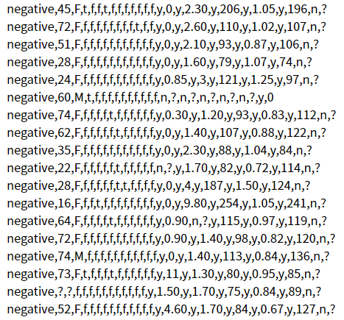
Data Set 2
- Name: Fertility Data Set– Fertility Diagnosis
- Source: UCI Machine Learning Repository
https://archive.ics.uci.edu/ml/datasets/Fertility
- Number of Instance: 100
- Description: 100 volunteers provide a semen sample analyzed according to the WHO 2010 criteria. Sperm concentration are related to socio-demographic data, environmental factors, health status, and life habits
- Missing Value: 0
- Number of Attribute: 10
- Attribute Information:
- Season in which the analysis was performed.
Winter: -1, Spring: -0.33, Summer: 0.33, Fall: 1
- Age at the time of analysis.
Between 18-36 years old: 1, others: 0
- Childish diseases (i.e. chicken pox, measles, mumps, polio)
No: 0, Yes: 1
- Accident or serious trauma
No: 0, Yes: 1
- Surgical intervention
No: 0, Yes: 1
- High fevers in the last year
Never: 1, More than three months ago: 0, Less than three months ago: -1
- Frequency of alcohol consumption
1) several times a day, 2) every day, 3) several times a week, 4) once a week, 5) hardly ever or never (0, 1)
- Smoking habit
Never: -1, Occasional: 0, Daily: 1
- Number of hours spent sitting per day
Continuous, 0~1
- Output: Diagnosis
Normal: N, Altered: O
- Data Set Preview
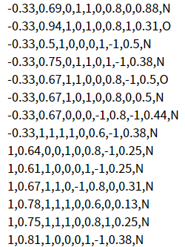

Part 2 – Visualizations
Data Set 1
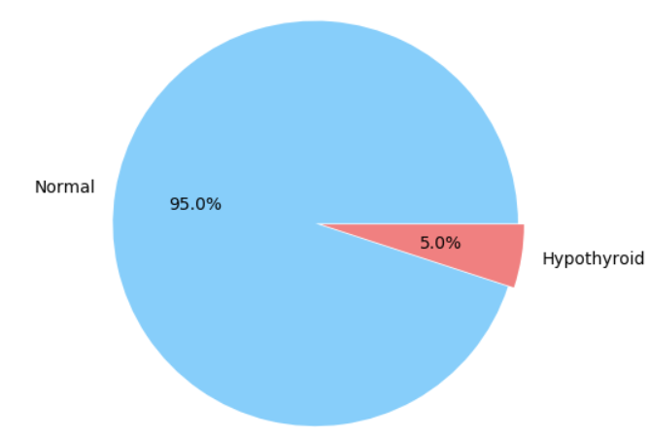
Figure 1-1: Percentage of people that is diagnosed as normal and Hypothyroid.
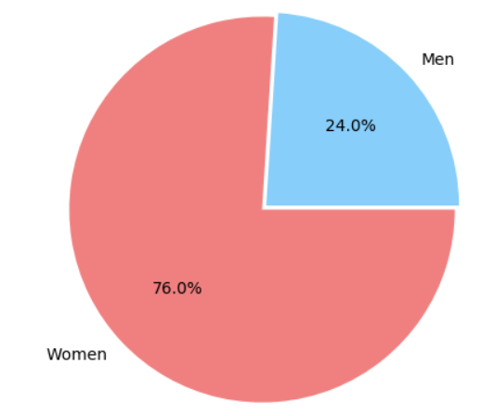
Figure 1-2: Percentage of different sex of all the ones having hypothyroid.
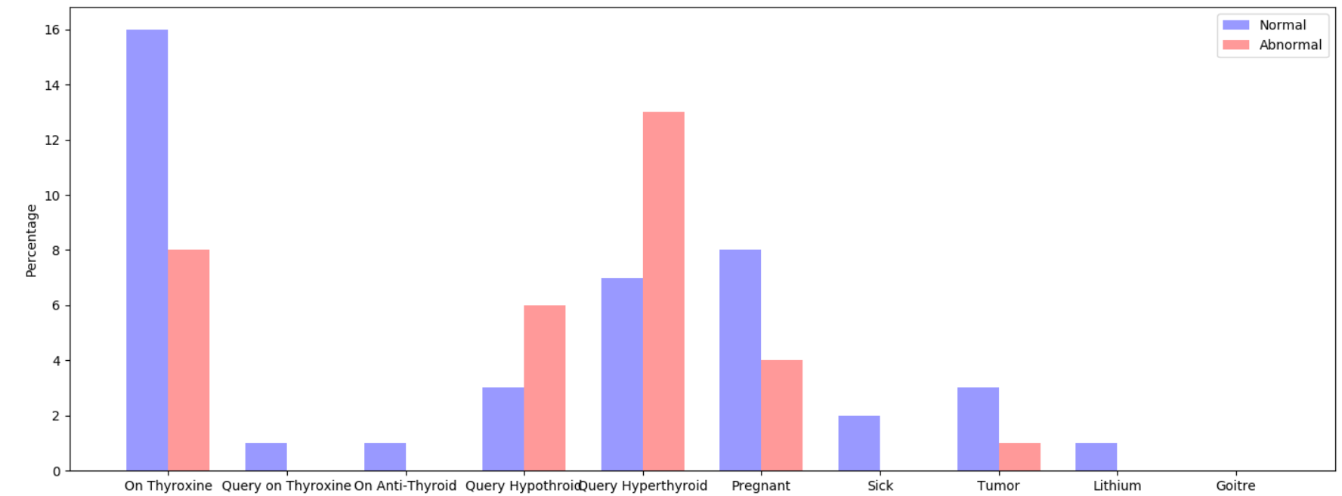
Figure 1-3: Bar chart showing the percentage of different condition and percentage of normal and hypothyroid.
Data Set 2
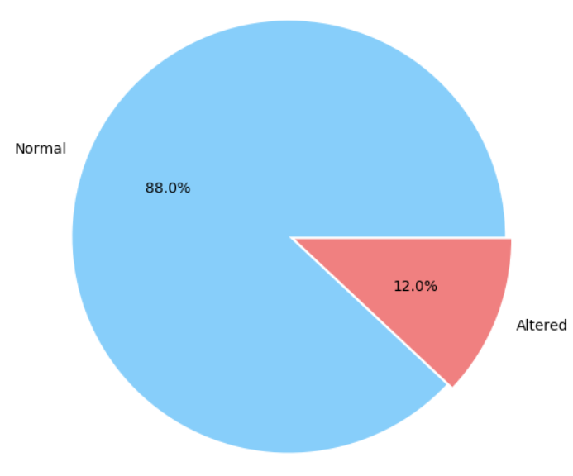
Figure 2-1: Percentage of people that is diagnosed as normal and altered.
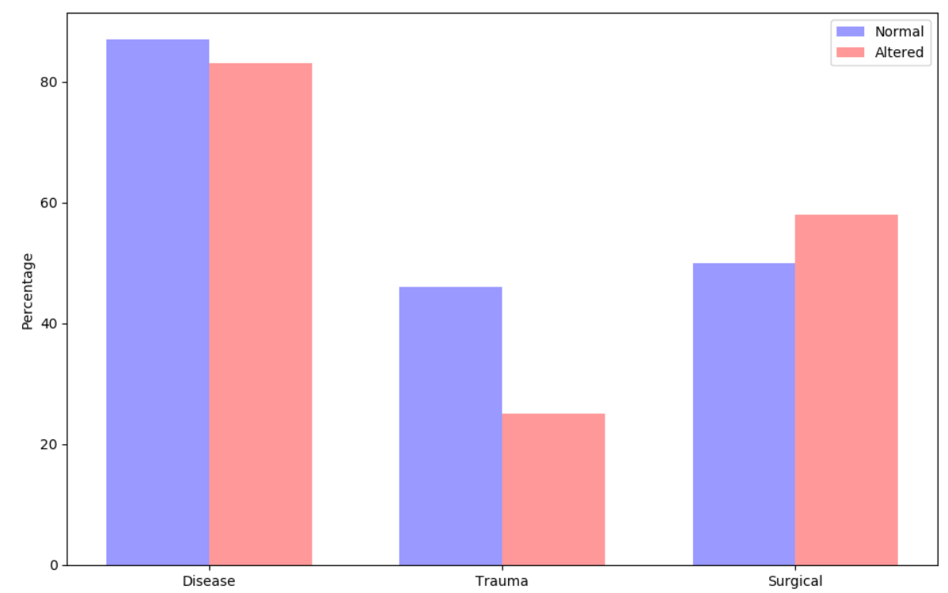
Figure 2-2: Bar chart showing the percentage of different condition and percentage of normal and altered.
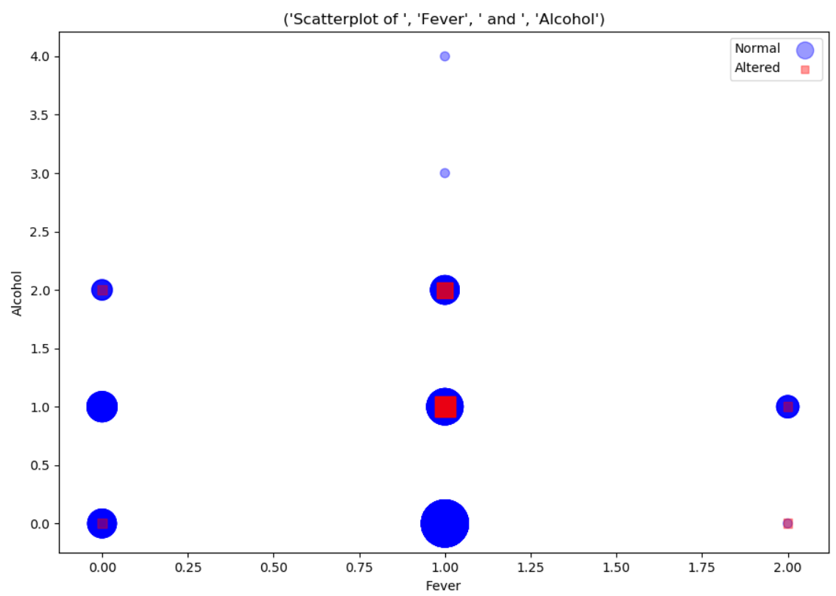
Figure 2-3: The scatter plot presents the relation between fever, alcohol and the condition of the semen.
Part 3 – Observations
Data Set 1
Figure 1-1
Percentage of people that is diagnosed as normal and Hypothyroid.
Blue means normal and red means hypothyroid.
We can see that most people do not have hypothyroid, and the percentage of people having is about 5 percent.
Figure 1-2
Percentage of different sex of all the ones having hypothyroid.
Blue means men and red means women.
From this figure, we can see that more than 3/4 of people having hypothyroid are female, because of that, we can assume that there might be some reason leading to female having higher rate than male to have hypothyroid.
Figure 1-3
Bar chart showing the percentage of different condition and percentage of normal and hypothyroid. The x-axis shows different conditions, which are: On Thyroxine, Query on Thyroxine, On Anti-Thyroid, Query Hypothyroid, Query Hyperthyroid, Pregnant, Sick, Tumor, Lithium and Goitre. The y-axis presents the percentage of people under each condition. The blue charts represent normal data and the red chart represent Hypothyroid data.
From this figure, we can briefly tell the relation between the percentage of normal and abnormal under each condition. By observing this figure, I found out that there isn’t a condition that has great effect on having hypothyroid or not due to the reason of the difference between the percentage of them are not too significant. The only two factors that may be considered are “On Thyroxine” and “Query Hyperthyroid”. For the factor “On Thyroxine”, the percentage of normal is almost twice as the percentage of abnormal, therefore, we can guess that people that are on thyroxine are more likely to not have hypothyroid. For the factor “Query Hyperthyroid”, the percentage of having hyperthyroid is about 1.5 times of the percentage of normal, we can make a guess that people who have hyperthyroid are more likely to query hyperthyroid than people who don’t have hyperthyroid.
Data Set 2
Figure 2-1
Percentage of people that is diagnosed as normal and altered.
Blue means normal and red means altered.
From this figure, we can tell that only 12% of people are have abnormal sperm, most of the people are having normal sperm.
Figure 2-2
Bar chart showing the percentage of different condition and percentage of normal and altered. The x-axis shows different conditions, which are: Disease, Trauma and Surgical. The y-axis presents the percentage of people under each condition of each group. The blue charts represent normal data and the red chart represent altered data.
From this figure, we can see the relation between each factor and the percentage of having normal or abnormal sperm. By observing this bar chart, I assume that these factors don’t have great effect in the normality of a men’s sperm, the reason of that is because under each condition, the percentage of normal and abnormal are similar. Take disease as example, both normal and abnormal have high percentage of having disease, therefore we assume that disease don’t have effect in the normality of a men’s sperm.
Figure 2-3
The scatter plot presents the relation between fever, alcohol and the condition of the semen. The x-axis present if the person has fever recently. 0 means not having fever in the last year, 1 means having fever more than three months age and 2 means having fever less than three months ago. The y-axis presents the frequency of having alcohol, 0 means hardly ever or never have alcohol, the larger the number is the more frequent the person have alcohol, the largest number 4 means having alcohol several times a day. Color blue represent the normal one and red represent altered one. The larger the scatter plot is indicated higher number of people.
By observing this scatter plot, we can found out that people who have fever more than three months ago are having the highest rate of have abnormal sperm, but we can not see any relation between the frequency of having alcohol, we can only see that people, including normal and abnormal, tends not to drink alcohol, the number of people decreased as the frequency of drinking alcohol raised. As for the percentage of people having fever, we can see that most people have fever more than three months age, and only have a few people have fever in the past three months. I guess that the main reason of not able to find any significant relation on this data set is mainly because the number of data set is too small, which is only a hundred data in this data set, if we are able to gain more data and have it visualized, be might be able to find some more significant relations among each factors.

Part 4 – Appendix
For this project, I complete all the program in Python, the following part is the code that I used to produce these visualized charts.
Data Set 1
In first step of this part, I first process the raw data and organize it into an easier format for further visualization
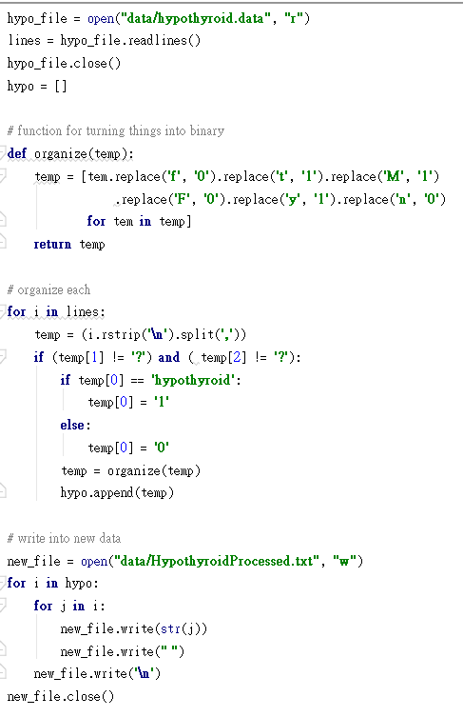
After this, the data attribute will become like this:
[00] Result 0 false 1 true
[01] Age age (int)
[02] Sex 0 Female 1 Male
[03] on thyroxine 0 false 1 true
[04] query on thyroxine 0 false 1 true
[05] on Anti-thyroid 0 false 1 true
[06] Surgery 0 false 1 true
[07] Query Hypothyroid 0 false 1 true
[08] Query Hyperthyroid 0 false 1 true
[09] Pregnant 0 normal 1 altered
[10] Sick 0 false 1 true
[11] Tumor 0 false 1 true
[12] Lithium 0 false 1 true
[13] Goiter 0 false 1 true
[14] TSH 0 false 1 true
[15] Num of TSH int or '?'
[16] T3 0 false 1 true
[17] Num of T3 int or '?'
[18] TT4 0 false 1 true
[19] Num of TT4 int or '?'
[20] T40 0 false 1 true
[21] Num of T40 int or '?'
[22] FTI 0 false 1 true
[23] Num of FTI int or '?'
[24] TBG 0 false 1 true
[25] Num of TBG int or '?'

Next, we will start to visualize the data
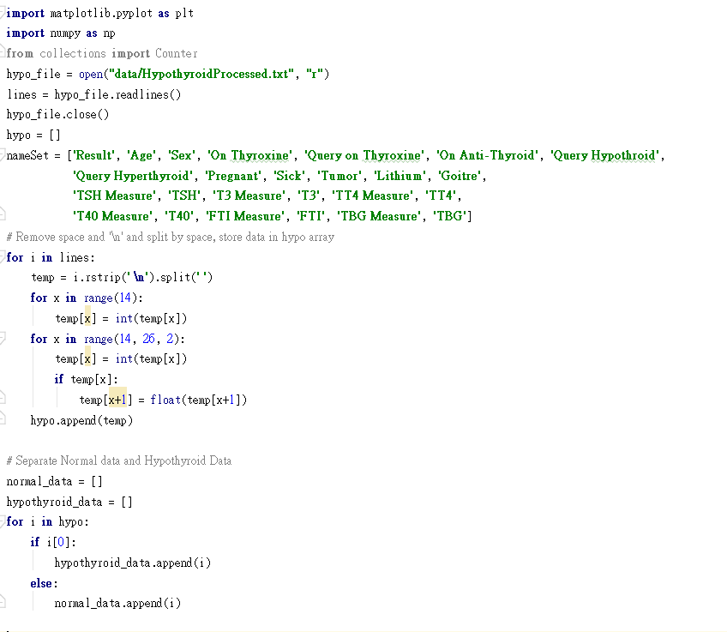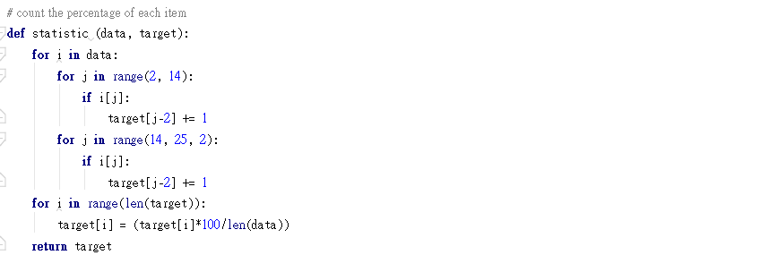

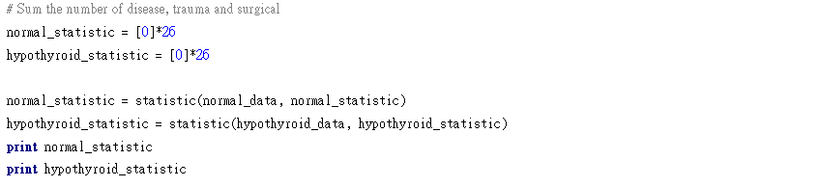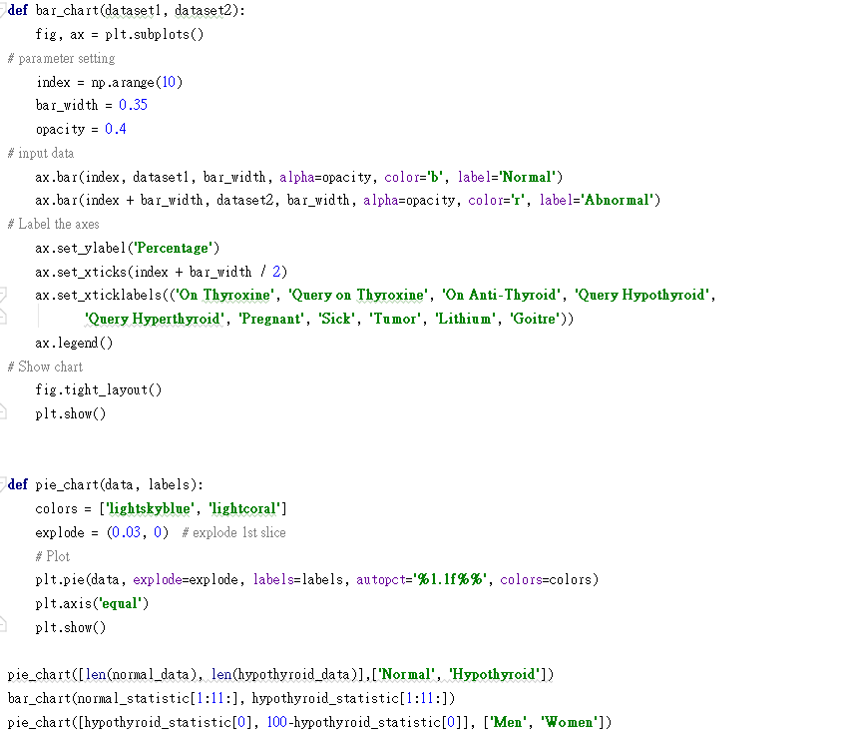
Data Set 2
In first step of this part, I first process the raw data and organize it into an easier format for further visualization
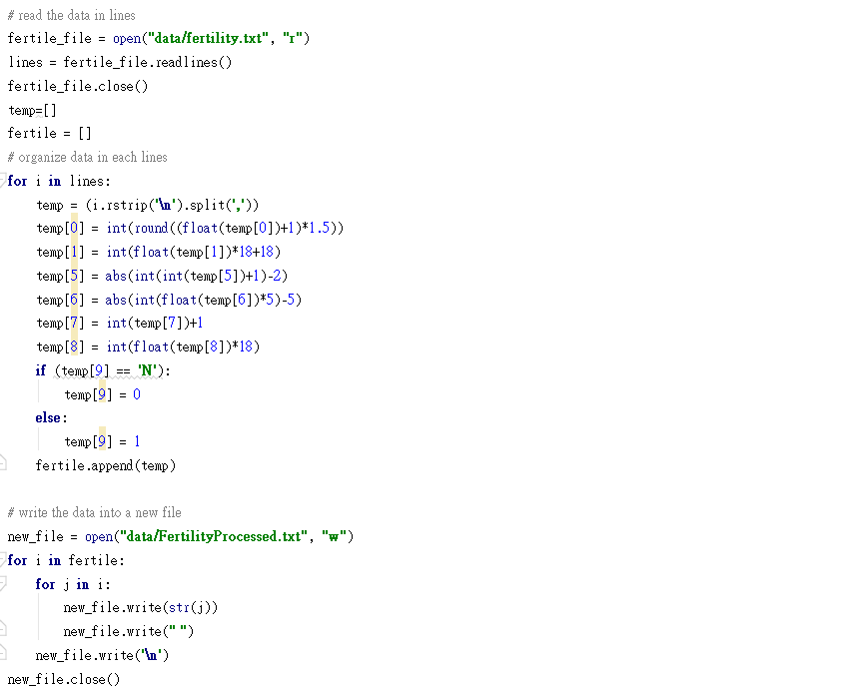
After this, the data attribute will become like this:
[0] Season 0 Winter, 1 Spring, 2 Summer, 3 Fall
[1] Age age (integer)
[2] Disease 0 false 1 true
[3] Trauma 0 false 1 true
[4] Surgical 0 false 1 true
[5] Fever 0 never 1 more than 3 months 2 less than 3 month
[6] Alcohol 4 n/day 3 1/day 2 n/week 1 1/week 0 never
[7] Smoke 0 never 1 sometime 2 daily
[8] Sit Hour hours(integer)
[9] Result 0 normal 1 altered
Next, we will start to visualize the data
